*Повтори чистоговорку:* Цо-цо-цо – на пальце кольцо.

*Отгадай загадку*: Пять братьев вместе родятся, а росту разного. (пальцы)

*Пальчиковая гимнастика*: Раз, два, три, четыре, пять,

Будем пальчики считать,

Все такие нужные,

Крепкие и дружные.

*Пересчитать пальчики и сжать в кулак. Проделать с обеими руками.*

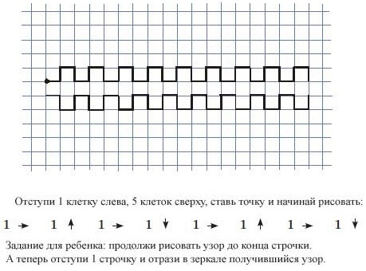

|  |  |  |  |  |  |  |  |  |  |  |  |  |  |  |  |  |  |  |  |  |  |
| --- | --- | --- | --- | --- | --- | --- | --- | --- | --- | --- | --- | --- | --- | --- | --- | --- | --- | --- | --- | --- | --- |
|  |  |  |  |  |  |  |  |  |  |  |  |  |  |  |  |  |  |  |  |  |  |
|  |  |  |  |  |  |  |  |  |  |  |  |  |  |  |  |  |  |  |  |  |  |
|  |  |  |  |  |  |  |  |  |  |  |  |  |  |  |  |  |  |  |  |  |  |
|  |  |  |  |  |  |  |  |  |  |  |  |  |  |  |  |  |  |  |  |  |  |
|  |  |  |  |  |  |  |  |  |  |  |  |  |  |  |  |  |  |  |  |  |  |
|  |  |  |  |  |  |  |  |  |  |  |  |  |  |  |  |  |  |  |  |  |  |
|  |  |  |  |  |  |  |  |  |  |  |  |  |  |  |  |  |  |  |  |  |  |
|  |  |  |  |  |  |  |  |  |  |  |  |  |  |  |  |  |  |  |  |  |  |
|  |  |  |  |  |  |  |  |  |  |  |  |  |  |  |  |  |  |  |  |  |  |
|  |  |  |  |  |  |  |  |  |  |  |  |  |  |  |  |  |  |  |  |  |  |
|  |  |  |  |  |  |  |  |  |  |  |  |  |  |  |  |  |  |  |  |  |  |

Скопируй простой узор.

*Скороговорка:* У ворчливой Варвары пропали варежки.

Варежки пропали у ворчливой Варвары.

*Повтори чистоговорку*: Си-си-си – синие перчатки у Васи.

Ся-ся-ся – надел перчатки Вася.

*Отгадай загадку*: Две плетенки, две сестрёнки

Из овечьей пряжи тонкой.

Как гулять - так надевать,

Чтоб не мёрзли пять да пять. (варежки)

*Пальчиковая гимнастика*: Перед тобой пятёрка братьев

Дома все они без платья,

А на улице зато

Нужно каждому пальто.

*Пальцы растопырить и повертеть ладонями. На последних двух строчках погладить каждый палец.*

|  |  |
| --- | --- |
|  | Отступаем 2 клетки слева, 2 клетки сверху, ставим точку и начинаем рисовать.  2 2 2 2 2 2 2 2  Задание для ребенка: продолжи рисовать узор до конца строчки. А теперь отступи 2 строчки и отрази в зеркале получившийся узор. |

|  |  |  |  |  |  |  |  |  |  |  |  |  |  |  |  |  |  |  |  |  |  |
| --- | --- | --- | --- | --- | --- | --- | --- | --- | --- | --- | --- | --- | --- | --- | --- | --- | --- | --- | --- | --- | --- |
|  |  |  |  |  |  |  |  |  |  |  |  |  |  |  |  |  |  |  |  |  |  |
|  |  |  |  |  |  |  |  |  |  |  |  |  |  |  |  |  |  |  |  |  |  |
|  |  |  |  |  |  |  |  |  |  |  |  |  |  |  |  |  |  |  |  |  |  |
|  |  |  |  |  |  |  |  |  |  |  |  |  |  |  |  |  |  |  |  |  |  |
|  |  |  |  |  |  |  |  |  |  |  |  |  |  |  |  |  |  |  |  |  |  |
|  |  |  |  |  |  |  |  |  |  |  |  |  |  |  |  |  |  |  |  |  |  |
|  |  |  |  |  |  |  |  |  |  |  |  |  |  |  |  |  |  |  |  |  |  |
|  |  |  |  |  |  |  |  |  |  |  |  |  |  |  |  |  |  |  |  |  |  |
|  |  |  |  |  |  |  |  |  |  |  |  |  |  |  |  |  |  |  |  |  |  |
|  |  |  |  |  |  |  |  |  |  |  |  |  |  |  |  |  |  |  |  |  |  |
|  |  |  |  |  |  |  |  |  |  |  |  |  |  |  |  |  |  |  |  |  |  |

Скопируй простой узор.

*Скороговорка:* Сон сморил сома. Сома сморил сон.

*Повтори чистоговорку*: Са-са-са – свернулась калачом лиса.

Се-се-се – спать пора лисе.

*Отгадай загадку*: На чёрный платок просыпано просо.

Пришел петушок, а склевать-то не просто. (звёзды)

Что видно только ночью? (звёзды)

*Пальчиковая гимнастика*: Этот пальчик хочет спать,

Этот пальчик лёг в кровать,

Этот пальчик чуть вздремнул,

Этот пальчик уж уснул,

Этот пальчик крепко спит. *Ребенок загибает пальчики*

Никто больше не шумит. *по очереди, начиная с мизинца.*

|  |  |
| --- | --- |
|  | Отступи 1 клетку слева, 4 клетки сверху, ставь точку и начинай рисовать.   1. 1   2 2   1. 1   1 1  1 1  2 2   1. 1   1 1  Задание для ребенка: продолжи рисовать узор до конца строчки. А теперь отступи две строчки и отрази в зеркале получившийся узор. |

|  |  |  |  |  |  |  |  |  |  |  |  |  |  |  |  |  |  |  |  |  |  |
| --- | --- | --- | --- | --- | --- | --- | --- | --- | --- | --- | --- | --- | --- | --- | --- | --- | --- | --- | --- | --- | --- |
|  |  |  |  |  |  |  |  |  |  |  |  |  |  |  |  |  |  |  |  |  |  |
|  |  |  |  |  |  |  |  |  |  |  |  |  |  |  |  |  |  |  |  |  |  |
|  |  |  |  |  |  |  |  |  |  |  |  |  |  |  |  |  |  |  |  |  |  |
|  |  |  |  |  |  |  |  |  |  |  |  |  |  |  |  |  |  |  |  |  |  |
|  |  |  |  |  |  |  |  |  |  |  |  |  |  |  |  |  |  |  |  |  |  |
|  |  |  |  |  |  |  |  |  |  |  |  |  |  |  |  |  |  |  |  |  |  |
|  |  |  |  |  |  |  |  |  |  |  |  |  |  |  |  |  |  |  |  |  |  |
|  |  |  |  |  |  |  |  |  |  |  |  |  |  |  |  |  |  |  |  |  |  |
|  |  |  |  |  |  |  |  |  |  |  |  |  |  |  |  |  |  |  |  |  |  |
|  |  |  |  |  |  |  |  |  |  |  |  |  |  |  |  |  |  |  |  |  |  |
|  |  |  |  |  |  |  |  |  |  |  |  |  |  |  |  |  |  |  |  |  |  |

Скопируй рисунок.

|  |  |
| --- | --- |
| Паровоз, Паровоз,  Что в подарок нам привез?  - Я привёз цветные книжки.  Пусть читают ребятишки!  Я привёз карандаши,  Пусть рисуют малыши!  Е. Благинина |  |

|  |  |  |  |  |  |  |  |  |  |  |  |  |  |  |  |  |  |  |  |  |  |
| --- | --- | --- | --- | --- | --- | --- | --- | --- | --- | --- | --- | --- | --- | --- | --- | --- | --- | --- | --- | --- | --- |
|  |  |  |  |  |  |  |  |  |  |  |  |  |  |  |  |  |  |  |  |  |  |
|  |  |  |  |  |  |  |  |  |  |  |  |  |  |  |  |  |  |  |  |  |  |
|  |  |  |  |  |  |  |  |  |  |  |  |  |  |  |  |  |  |  |  |  |  |
|  |  |  |  |  |  |  |  |  |  |  |  |  |  |  |  |  |  |  |  |  |  |
|  |  |  |  |  |  |  |  |  |  |  |  |  |  |  |  |  |  |  |  |  |  |
|  |  |  |  |  |  |  |  |  |  |  |  |  |  |  |  |  |  |  |  |  |  |
|  |  |  |  |  |  |  |  |  |  |  |  |  |  |  |  |  |  |  |  |  |  |
|  |  |  |  |  |  |  |  |  |  |  |  |  |  |  |  |  |  |  |  |  |  |

Задание для ребят: подумайте, как можно нарисовать то, что везёт паровозик. *(книжки и карандаши).* Какие геометрические фигуры вы будете использовать при рисовании этих предмеов? *(прямоугольники, треугольники, квадраты).* Раскрасьте свои рисунки.

|  |  |  |  |  |  |  |  |  |  |  |  |  |  |  |  |  |  |  |  |  |  |
| --- | --- | --- | --- | --- | --- | --- | --- | --- | --- | --- | --- | --- | --- | --- | --- | --- | --- | --- | --- | --- | --- |
|  |  |  |  |  |  |  |  |  |  |  |  |  |  |  |  |  |  |  |  |  |  |
|  |  |  |  |  |  |  |  |  |  |  |  |  |  |  |  |  |  |  |  |  |  |
|  |  |  |  |  |  |  |  |  |  |  |  |  |  |  |  |  |  |  |  |  |  |
|  |  |  |  |  |  |  |  |  |  |  |  |  |  |  |  |  |  |  |  |  |  |
|  |  |  |  |  |  |  |  |  |  |  |  |  |  |  |  |  |  |  |  |  |  |
|  |  |  |  |  |  |  |  |  |  |  |  |  |  |  |  |  |  |  |  |  |  |
|  |  |  |  |  |  |  |  |  |  |  |  |  |  |  |  |  |  |  |  |  |  |
|  |  |  |  |  |  |  |  |  |  |  |  |  |  |  |  |  |  |  |  |  |  |
|  |  |  |  |  |  |  |  |  |  |  |  |  |  |  |  |  |  |  |  |  |  |

- Сегодня к нам в гости пришли весёлые человечки. Посмотрите. Из каких фигур они состоят? *(треугольник, прямоугольник, ромб, овал, круг).*

Задание для ребят: скопируй и раскрась рисунок.

|  |  |
| --- | --- |
| **Треугольник** - три угла, Посмотрите детвора: Три вершины очень острых - Треугольник – «остроносый».  Стороны в нем тоже три: Раз, два, три – ты посмотри. Треугольник мы рисуем, Знать теперь его мы будем. | Вот овальный огуречик, Из него и человечек Получиться может ловко: Ручки, ножки и головка.  Наш **овал** нам сделать просто: Круг растянем – больше роста. Нет углов и нет сторон, Очень вытянутый он. |
| **Ромб** - фигура непростая, Две в себе объединяет: Треугольник раз и два - Фигура стала вдруг одна.  Четыре в ромбе стороны. Между собой они равны. Четыре в ромбе и угла, Равны между собой по два. | Как окно **прямоугольник**, Аккуратный, словно школьник. Он похож на дверь, на книжки, И на ранец у мальчишки.  На автобус, на тетрадку, На большую шоколадку. На корыто поросенка И на фантик у ребенка. |

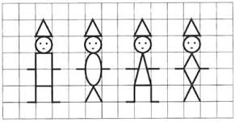

|  |  |  |  |  |  |  |  |  |  |  |  |  |  |  |  |  |  |  |  |  |  |
| --- | --- | --- | --- | --- | --- | --- | --- | --- | --- | --- | --- | --- | --- | --- | --- | --- | --- | --- | --- | --- | --- |
|  |  |  |  |  |  |  |  |  |  |  |  |  |  |  |  |  |  |  |  |  |  |
|  |  |  |  |  |  |  |  |  |  |  |  |  |  |  |  |  |  |  |  |  |  |
|  |  |  |  |  |  |  |  |  |  |  |  |  |  |  |  |  |  |  |  |  |  |
|  |  |  |  |  |  |  |  |  |  |  |  |  |  |  |  |  |  |  |  |  |  |
|  |  |  |  |  |  |  |  |  |  |  |  |  |  |  |  |  |  |  |  |  |  |
|  |  |  |  |  |  |  |  |  |  |  |  |  |  |  |  |  |  |  |  |  |  |
|  |  |  |  |  |  |  |  |  |  |  |  |  |  |  |  |  |  |  |  |  |  |
|  |  |  |  |  |  |  |  |  |  |  |  |  |  |  |  |  |  |  |  |  |  |
|  |  |  |  |  |  |  |  |  |  |  |  |  |  |  |  |  |  |  |  |  |  |

Скопируй и раскрась рисунки.

|  |  |  |  |  |  |  |  |  |  |  |  |  |  |  |  |  |  |  |  |  |  |  |  |  |  |  |  |  |  |  |  |  |  |  |  |  |  |  |  |  |  |  |  |  |  |  |  |  |  |  |  |  |  |  |  |  |  |  |  |  |  |  |  |  |  |  |  |  |  |  |  |  |  |  |  |  |  |  |  |  |  |  |  |  |  |  |  |  |  |  |  |  |  |  |  |  |  |  |  |  |  |  |  |  |  |  |  |  |  |  |  |  |  |  |  |  |  |  |  |  |  |  |  |  |  |  |  |  |  |  |  |  |  |  |  |  |  |  |  |  |  |  |  |  |  |  |  |  |  |  |  |  |  |  |  |  |  |  |  |  |  |  |  |  |  |  |  |  |  |  |  |  |  |  |  |  |  |  |  |  |  |  |  |  |  |  |  |  |  |  |  |  |  |  |  |  |  |  |  |  |  |  |  |  |  |  |  |  |  |  |  |  |  |  |  |  |  |  |  |  |  |  |  |  |  |  |  |  |  |  |  |  |  |  |  |  |  |  |  |  |  |  |  |  |  |  |  |  |  |  |  |  |  |  |  |  |  |  |  |  |  |  |  |  |  |  |  |  |  |  |  |  |  |  |  |  |  |  |  |  |  |  |  |  |  |  |  |  |  |  |  |  |  |  |  |  |  |  |  |  |  |  |  |  |  |  |  |  |  |  |  |  |  |  |  |  |  |  |  |  |  |  |  |  |  |  |  |  |  |  |  |  |  |  |  |  |  |  |  |  |  |  |  |  |  |  |  |  |  |  |  |  |  |  |  |  |  |  |  |  |  |  |  |  |  |  |  |  |  |  |  |  |  |  |  |  |  |  |  |  |  |  |  |  |  |  |  |  |  |  |  |  |  |  |  |  |  |  |  |  |  |  |  |  |  |  |  |  |  |  |  |  |  |  |  |  |  |  |  |  |  |  |  |  |  |  |  |  |  |  |  |  |  |  |  |
| --- | --- | --- | --- | --- | --- | --- | --- | --- | --- | --- | --- | --- | --- | --- | --- | --- | --- | --- | --- | --- | --- | --- | --- | --- | --- | --- | --- | --- | --- | --- | --- | --- | --- | --- | --- | --- | --- | --- | --- | --- | --- | --- | --- | --- | --- | --- | --- | --- | --- | --- | --- | --- | --- | --- | --- | --- | --- | --- | --- | --- | --- | --- | --- | --- | --- | --- | --- | --- | --- | --- | --- | --- | --- | --- | --- | --- | --- | --- | --- | --- | --- | --- | --- | --- | --- | --- | --- | --- | --- | --- | --- | --- | --- | --- | --- | --- | --- | --- | --- | --- | --- | --- | --- | --- | --- | --- | --- | --- | --- | --- | --- | --- | --- | --- | --- | --- | --- | --- | --- | --- | --- | --- | --- | --- | --- | --- | --- | --- | --- | --- | --- | --- | --- | --- | --- | --- | --- | --- | --- | --- | --- | --- | --- | --- | --- | --- | --- | --- | --- | --- | --- | --- | --- | --- | --- | --- | --- | --- | --- | --- | --- | --- | --- | --- | --- | --- | --- | --- | --- | --- | --- | --- | --- | --- | --- | --- | --- | --- | --- | --- | --- | --- | --- | --- | --- | --- | --- | --- | --- | --- | --- | --- | --- | --- | --- | --- | --- | --- | --- | --- | --- | --- | --- | --- | --- | --- | --- | --- | --- | --- | --- | --- | --- | --- | --- | --- | --- | --- | --- | --- | --- | --- | --- | --- | --- | --- | --- | --- | --- | --- | --- | --- | --- | --- | --- | --- | --- | --- | --- | --- | --- | --- | --- | --- | --- | --- | --- | --- | --- | --- | --- | --- | --- | --- | --- | --- | --- | --- | --- | --- | --- | --- | --- | --- | --- | --- | --- | --- | --- | --- | --- | --- | --- | --- | --- | --- | --- | --- | --- | --- | --- | --- | --- | --- | --- | --- | --- | --- | --- | --- | --- | --- | --- | --- | --- | --- | --- | --- | --- | --- | --- | --- | --- | --- | --- | --- | --- | --- | --- | --- | --- | --- | --- | --- | --- | --- | --- | --- | --- | --- | --- | --- | --- | --- | --- | --- | --- | --- | --- | --- | --- | --- | --- | --- | --- | --- | --- | --- | --- | --- | --- | --- | --- | --- | --- | --- | --- | --- | --- | --- | --- | --- | --- | --- | --- | --- | --- | --- | --- | --- | --- | --- | --- | --- | --- | --- | --- | --- | --- | --- | --- | --- | --- | --- | --- | --- | --- | --- | --- | --- | --- | --- | --- | --- | --- | --- | --- | --- | --- | --- | --- | --- | --- | --- | --- | --- | --- | --- | --- | --- | --- | --- | --- | --- | --- | --- | --- | --- | --- | --- | --- | --- | --- | --- | --- | --- | --- | --- | --- | --- | --- | --- | --- | --- | --- | --- | --- | --- | --- | --- | --- | --- | --- | --- | --- |
|  | |  |  |  |  |  |  |  |  |  |  |  |  |  |  | | --- | --- | --- | --- | --- | --- | --- | --- | --- | --- | --- | --- | --- | --- | |  |  |  |  |  |  |  |  |  |  |  |  |  |  | |  |  |  |  |  |  |  |  |  |  |  |  |  |  | |  |  |  |  |  |  |  |  |  |  |  |  |  |  | |  |  |  |  |  |  |  |  |  |  |  |  |  |  | |  |  |  |  |  |  |  |  |  |  |  |  |  |  | |  |  |  |  |  |  |  |  |  |  |  |  |  |  | |  |  |  |  |  |  |  |  |  |  |  |  |  |  | |  |  |  |  |  |  |  |  |  |  |  |  |  |  | |  |  |  |  |  |  |  |  |  |  |  |  |  |  | |  |  |  |  |  |  |  |  |  |  |  |  |  |  | |  |  |  |  |  |  |  |  |  |  |  |  |  |  | |  |  |  |  |  |  |  |  |  |  |  |  |  |  | |  |  |  |  |  |  |  |  |  |  |  |  |  |  | |  |  |  |  |  |  |  |  |  |  |  |  |  |  | |  |  |  |  |  |  |  |  |  |  |  |  |  |  | |  |  |  |  |  |  |  |  |  |  |  |  |  |  | |  |  |  |  |  |  |  |  |  |  |  |  |  |  | |  |  |  |  |  |  |  |  |  |  |  |  |  |  | |  |  |  |  |  |  |  |  |  |  |  |  |  |  | |  |  |  |  |  |  |  |  |  |  |  |  |  |  | |  |  |  |  |  |  |  |  |  |  |  |  |  |  | |  |  |  |  |  |  |  |  |  |  |  |  |  |  | |  |  |  |  |  |  |  |  |  |  |  |  |  |  | |  |  |  |  |  |  |  |  |  |  |  |  |  |  | |  |  |  |  |  |  |  |  |  |  |  |  |  |  | |  |  |  |  |  |  |  |  |  |  |  |  |  |  | |  |  |  |  |  |  |  |  |  |  |  |  |  |  | |  |  |  |  |  |  |  |  |  |  |  |  |  |  | |  |  |  |  |  |  |  |  |  |  |  |  |  |  | |  |  |  |  |  |  |  |  |  |  |  |  |  |  | |  |  |  |  |  |  |  |  |  |  |  |  |  |  | |

- Ребята, пройдет совсем немного времени, и вы пойдёте в школу. Там вы получите новые знания, многому научитесь. Что же необходимо первокласснику, какие школьные принадлежности? *(ручка, карандаш, пенал, портфель и т.*

Задание для ребят: скопируйте и раскрась рисунки.

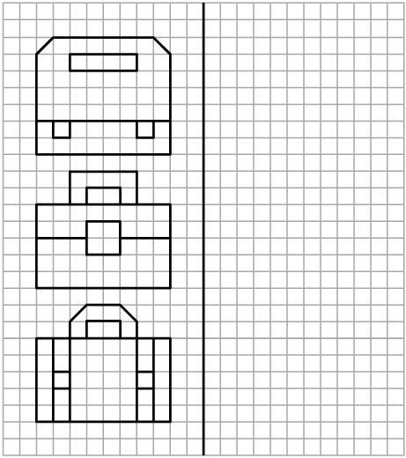

Задание для ребенка: от заданной точки двигайся, отсчитывая нужное количество клеток и не отрывая карандаша от бумаги. Внимательно слушай, не отвлекайся и увидишь, что получиться.

|  |  |  |  |  |  |  |  |  |  |  |  |  |  |  |  |  |  |  |  |  |
| --- | --- | --- | --- | --- | --- | --- | --- | --- | --- | --- | --- | --- | --- | --- | --- | --- | --- | --- | --- | --- |
|  |  |  |  |  |  |  |  |  |  |  |  |  |  |  |  |  |  |  |  |  |
|  |  |  |  |  |  |  |  |  |  |  |  |  |  |  |  |  |  |  |  |  |
|  |  |  |  |  |  |  |  |  |  |  |  |  |  |  |  |  |  |  |  |  |
|  |  |  |  |  |  |  |  |  |  |  |  |  |  |  |  |  |  |  |  |  |
|  |  |  |  |  |  |  |  |  |  |  |  |  |  |  |  |  |  |  |  |  |
|  |  |  |  |  |  |  |  |  |  |  |  |  |  |  |  |  |  |  |  |  |
|  |  |  |  |  |  |  |  |  |  |  |  |  |  |  |  |  |  |  |  |  |
|  |  |  |  |  |  |  |  |  |  |  |  |  |  |  |  |  |  |  |  |  |
|  |  |  |  |  |  |  |  |  |  |  |  |  |  |  |  |  |  |  |  |  |
|  |  |  |  |  |  |  |  |  |  |  |  |  |  |  |  |  |  |  |  |  |
|  |  |  |  |  |  |  |  |  |  |  |  |  |  |  |  |  |  |  |  |  |
|  |  |  |  |  |  |  |  |  |  |  |  |  |  |  |  |  |  |  |  |  |
|  |  |  |  |  |  |  |  |  |  |  |  |  |  |  |  |  |  |  |  |  |
|  |  |  |  |  |  |  |  |  |  |  |  |  |  |  |  |  |  |  |  |  |

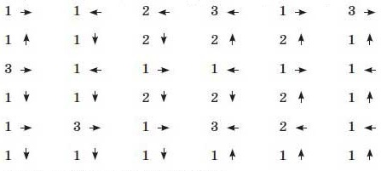

- Что получилось? (*робот*). Раскрась рисунок.

*Скороговорка*: Робот роботу делал, *Повтори чистоговорку*:

Делал да не переделал. Ро-ро-ро – робот, ру-ру-ру – рубит.

Скопируй и раскрась рисунок.

|  |  |  |  |  |  |  |  |  |  |  |  |  |  |  |  |  |  |  |  |  |  |  |  |
| --- | --- | --- | --- | --- | --- | --- | --- | --- | --- | --- | --- | --- | --- | --- | --- | --- | --- | --- | --- | --- | --- | --- | --- |
| *Скороговорка*:  Белые носочки на лапах у щенка.  Видно, перешел он речку молока.  *Повтори чистоговорку*:  Пёс лису учуять смог –  Сразу подал голосок.  Унеслась лиса в лесок –  Сала дали псу кусок.  *Отгадай загадку:*  Заворчал живой замок, Лёг у двери поперёк. Две медали на груди. Лучше в дом не заходи! **(Собака)** | | | | | | | | | | | |  | | | | | | | | | | | |
|  |  |  |  |  |  |  |  |  |  |  |  | |  |  |  |  |  |  |  |  |  |  |  |
|  |  |  |  |  |  |  |  |  |  |  |  | |  |  |  |  |  |  |  |  |  |  |  |
|  |  |  |  |  |  |  |  |  |  |  |  | |  |  |  |  |  |  |  |  |  |  |  |
|  |  |  |  |  |  |  |  |  |  |  |  | |  |  |  |  |  |  |  |  |  |  |  |
|  |  |  |  |  |  |  |  |  |  |  |  | |  |  |  |  |  |  |  |  |  |  |  |
|  |  |  |  |  |  |  |  |  |  |  |  | |  |  |  |  |  |  |  |  |  |  |  |
|  |  |  |  |  |  |  |  |  |  |  |  | |  |  |  |  |  |  |  |  |  |  |  |
|  |  |  |  |  |  |  |  |  |  |  |  | |  |  |  |  |  |  |  |  |  |  |  |
|  |  |  |  |  |  |  |  |  |  |  |  | |  |  |  |  |  |  |  |  |  |  |  |
|  |  |  |  |  |  |  |  |  |  |  |  | |  |  |  |  |  |  |  |  |  |  |  |
|  |  |  |  |  |  |  |  |  |  |  |  | |  |  |  |  |  |  |  |  |  |  |  |
|  |  |  |  |  |  |  |  |  |  |  |  | |  |  |  |  |  |  |  |  |  |  |  |
|  |  |  |  |  |  |  |  |  |  |  |  | |  |  |  |  |  |  |  |  |  |  |  |
|  |  |  |  |  |  |  |  |  |  |  |  | |  |  |  |  |  |  |  |  |  |  |  |
|  |  |  |  |  |  |  |  |  |  |  |  | |  |  |  |  |  |  |  |  |  |  |  |
|  |  |  |  |  |  |  |  |  |  |  |  | |  |  |  |  |  |  |  |  |  |  |  |
|  |  |  |  |  |  |  |  |  |  |  |  | |  |  |  |  |  |  |  |  |  |  |  |

Задание для ребенка: от заданной точки двигайся, отсчитывая нужное количество клеток и не отрывая карандаша от бумаги. Внимательно слушай, не отвлекайся и увидишь, что получиться.

|  |  |  |  |  |  |  |  |  |  |  |  |  |  |  |  |  |  |  |  |  |
| --- | --- | --- | --- | --- | --- | --- | --- | --- | --- | --- | --- | --- | --- | --- | --- | --- | --- | --- | --- | --- |
|  |  |  |  |  |  |  |  |  |  |  |  |  |  |  |  |  |  |  |  |  |
|  |  |  |  |  |  |  |  |  |  |  |  |  |  |  |  |  |  |  |  |  |
|  |  |  |  |  |  |  |  |  |  |  |  |  |  |  |  |  |  |  |  |  |
|  |  |  |  |  |  |  |  |  |  |  |  |  |  |  |  |  |  |  |  |  |
|  |  |  |  |  |  |  |  |  |  |  |  |  |  |  |  |  |  |  |  |  |
|  |  |  |  |  |  |  |  |  |  |  |  |  |  |  |  |  |  |  |  |  |
|  |  |  |  |  |  |  |  |  |  |  |  |  |  |  |  |  |  |  |  |  |
|  |  |  |  |  |  |  |  |  |  |  |  |  |  |  |  |  |  |  |  |  |
|  |  |  |  |  |  |  |  |  |  |  |  |  |  |  |  |  |  |  |  |  |
|  |  |  |  |  |  |  |  |  |  |  |  |  |  |  |  |  |  |  |  |  |
|  |  |  |  |  |  |  |  |  |  |  |  |  |  |  |  |  |  |  |  |  |
|  |  |  |  |  |  |  |  |  |  |  |  |  |  |  |  |  |  |  |  |  |
|  |  |  |  |  |  |  |  |  |  |  |  |  |  |  |  |  |  |  |  |  |
|  |  |  |  |  |  |  |  |  |  |  |  |  |  |  |  |  |  |  |  |  |

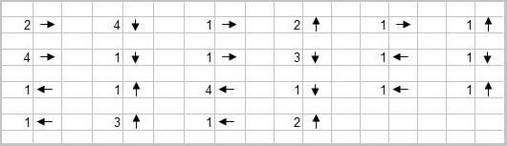

|  |  |
| --- | --- |
| Что получилось? Раскрась рисунок.  *Запомни считалочку*:  Черепаха хвост поджала,  И за зайцем побежала.  Оказалась впереди.  Кто не верит – выходи. | **Черепаха, не скучая,** *Расставить пальцы правой руки и опереться всеми, кроме среднего, на стол – получатся «ноги»; средний палец согнуть – «голова»; левой рукой обхватить правую – «панцирь».* **Час сидит за чашкой чая**. *Сложить ладони так, чтобы получился «ковшик».* **А куда спешить тому**, *Развести руки в стороны, выразить удивление на лице.* **Кто всегда в своем дому?** |

Посмотрите, ребята, кто собрался на нашей страничке? (*ёж, жук и цыплёнок*). Вспомни, к какому отряду относятся эти живые существа (ёж – дикое животное, жук – насекомое, цыплёнок – домашняя птица). Чем они питаются? Где обитают?

Задание для ребят: скопируй и раскрась рисунки. Попробуй придумать рассказ и подружить их.

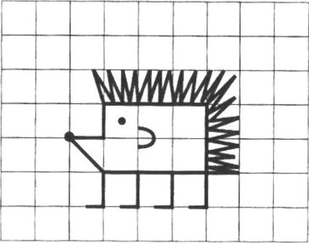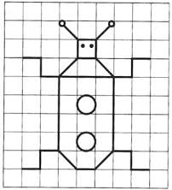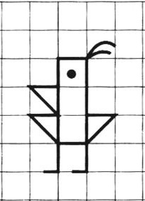

|  |  |  |  |  |  |  |  |  |  |  |  |  |  |  |  |  |  |  |  |  |
| --- | --- | --- | --- | --- | --- | --- | --- | --- | --- | --- | --- | --- | --- | --- | --- | --- | --- | --- | --- | --- |
|  |  |  |  |  |  |  |  |  |  |  |  |  |  |  |  |  |  |  |  |  |
|  |  |  |  |  |  |  |  |  |  |  |  |  |  |  |  |  |  |  |  |  |
|  |  |  |  |  |  |  |  |  |  |  |  |  |  |  |  |  |  |  |  |  |
|  |  |  |  |  |  |  |  |  |  |  |  |  |  |  |  |  |  |  |  |  |
|  |  |  |  |  |  |  |  |  |  |  |  |  |  |  |  |  |  |  |  |  |
|  |  |  |  |  |  |  |  |  |  |  |  |  |  |  |  |  |  |  |  |  |
|  |  |  |  |  |  |  |  |  |  |  |  |  |  |  |  |  |  |  |  |  |
|  |  |  |  |  |  |  |  |  |  |  |  |  |  |  |  |  |  |  |  |  |
|  |  |  |  |  |  |  |  |  |  |  |  |  |  |  |  |  |  |  |  |  |
|  |  |  |  |  |  |  |  |  |  |  |  |  |  |  |  |  |  |  |  |  |
|  |  |  |  |  |  |  |  |  |  |  |  |  |  |  |  |  |  |  |  |  |
|  |  |  |  |  |  |  |  |  |  |  |  |  |  |  |  |  |  |  |  |  |
|  |  |  |  |  |  |  |  |  |  |  |  |  |  |  |  |  |  |  |  |  |
|  |  |  |  |  |  |  |  |  |  |  |  |  |  |  |  |  |  |  |  |  |
|  |  |  |  |  |  |  |  |  |  |  |  |  |  |  |  |  |  |  |  |  |

Задание дополнительное (по желанию): прояви фантазию и дорисуй самостоятельно угощение для каждого из друзей.

Задание для ребенка: от заданной точки двигайся, отсчитывая нужное количество клеток и не отрывая карандаша от бумаги. Внимательно слушай, не отвлекайся и увидишь, что получиться.

|  |  |  |  |  |  |  |  |  |  |  |  |  |  |  |  |  |  |  |  |  |  |
| --- | --- | --- | --- | --- | --- | --- | --- | --- | --- | --- | --- | --- | --- | --- | --- | --- | --- | --- | --- | --- | --- |
|  |  |  |  |  |  |  |  |  |  |  |  |  |  |  |  |  |  |  |  |  |  |
|  |  |  |  |  |  |  |  |  |  |  |  |  |  |  |  |  |  |  |  |  |  |
|  |  |  |  |  |  |  |  |  |  |  |  |  |  |  |  |  |  |  |  |  |  |
|  |  |  |  |  |  |  |  |  |  |  |  |  |  |  |  |  |  |  |  |  |  |
|  |  |  |  |  |  |  |  |  |  |  |  |  |  |  |  |  |  |  |  |  |  |
|  |  |  |  |  |  |  |  |  |  |  |  |  |  |  |  |  |  |  |  |  |  |
|  |  |  |  |  |  |  |  |  |  |  |  |  |  |  |  |  |  |  |  |  |  |
|  |  |  |  |  |  |  |  |  |  |  |  |  |  |  |  |  |  |  |  |  |  |
|  |  |  |  |  |  |  |  |  |  |  |  |  |  |  |  |  |  |  |  |  |  |
|  |  |  |  |  |  |  |  |  |  |  |  |  |  |  |  |  |  |  |  |  |  |
|  |  |  |  |  |  |  |  |  |  |  |  |  |  |  |  |  |  |  |  |  |  |
|  |  |  |  |  |  |  |  |  |  |  |  |  |  |  |  |  |  |  |  |  |  |
|  |  |  |  |  |  |  |  |  |  |  |  |  |  |  |  |  |  |  |  |  |  |
|  |  |  |  |  |  |  |  |  |  |  |  |  |  |  |  |  |  |  |  |  |  |
|  |  |  |  |  |  |  |  |  |  |  |  |  |  |  |  |  |  |  |  |  |  |
|  |  |  |  |  |  |  |  |  |  |  |  |  |  |  |  |  |  |  |  |  |  |
|  |  |  |  |  |  |  |  |  |  |  |  |  |  |  |  |  |  |  |  |  |  |
|  |  |  |  |  |  |  |  |  |  |  |  |  |  |  |  |  |  |  |  |  |  |
|  |  |  |  |  |  |  |  |  |  |  |  |  |  |  |  |  |  |  |  |  |  |
|  |  |  |  |  |  |  |  |  |  |  |  |  |  |  |  |  |  |  |  |  |  |
|  |  |  |  |  |  |  |  |  |  |  |  |  |  |  |  |  |  |  |  |  |  |
|  |  |  |  |  |  |  |  |  |  |  |  |  |  |  |  |  |  |  |  |  |  |

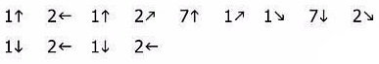

|  |  |
| --- | --- |
| До Луны не может птица Долететь и прилуниться, Но зато умеет это Делать быстрая … (Ракета) | *Скороговорка*: Прилунился лунолет,  В лунолёте – луноход. |

Разминка для руки.

Задание для ребенка: продолжи узор для конца строчки. Сделай это красиво и аккуратно.

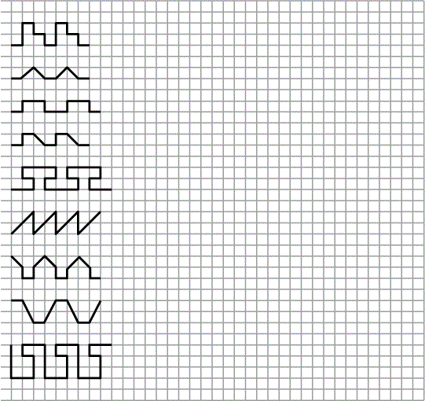

- Ребята, сегодня мы попробуем новый способ графического диктанта.

Задание для ребят: скопируй рисунок в зеркальном отражении. Из половинки получишь целое. Раскрась рисунки.

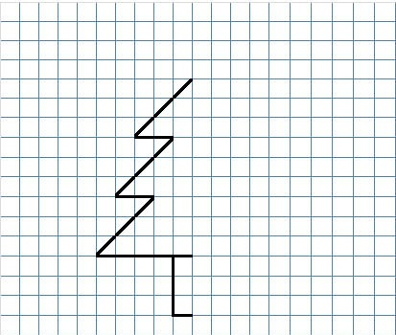

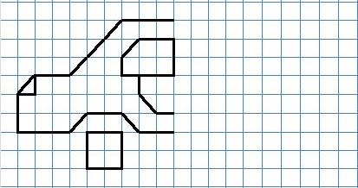

Задание для ребят: скопируй рисунок в зеркальном отражении. Раскрась животных.

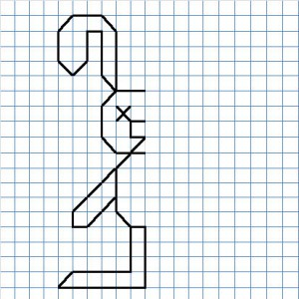

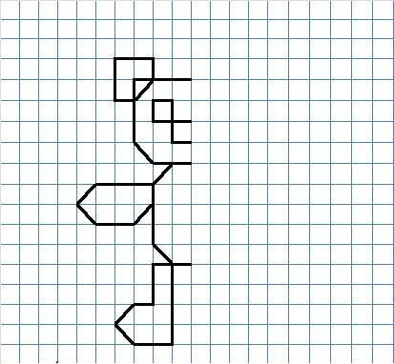

Задание для ребят: скопируй рисунок в зеркальном отражении. Раскрась рисунки.

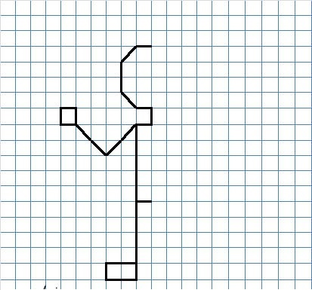

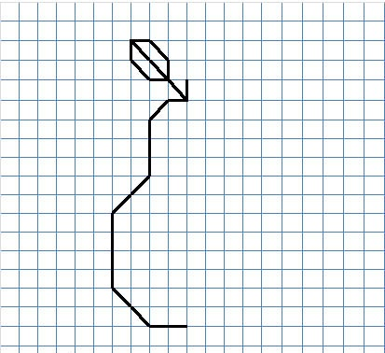

Задание для ребят: скопируй рисунок в зеркальном отражении. Раскрась рисунок.

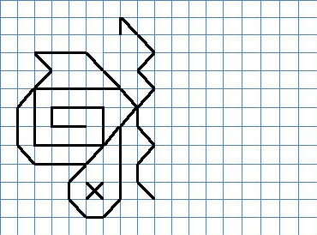

|  |  |  |  |  |  |  |  |  |  |  |  |  |  |  |  |  |  |  |  |  |  |  |  |  |  |  |  |  |  |  |  |  |  |  |  |  |  |  |  |  |  |  |  |  |  |  |  |  |  |  |  |  |  |  |  |  |  |  |  |  |  |  |  |  |  |  |  |  |  |  |  |  |  |  |  |  |  |  |  |  |  |  |  |  |  |  |  |  |  |  |  |  |  |  |  |  |  |  |  |
| --- | --- | --- | --- | --- | --- | --- | --- | --- | --- | --- | --- | --- | --- | --- | --- | --- | --- | --- | --- | --- | --- | --- | --- | --- | --- | --- | --- | --- | --- | --- | --- | --- | --- | --- | --- | --- | --- | --- | --- | --- | --- | --- | --- | --- | --- | --- | --- | --- | --- | --- | --- | --- | --- | --- | --- | --- | --- | --- | --- | --- | --- | --- | --- | --- | --- | --- | --- | --- | --- | --- | --- | --- | --- | --- | --- | --- | --- | --- | --- | --- | --- | --- | --- | --- | --- | --- | --- | --- | --- | --- | --- | --- | --- | --- | --- | --- | --- | --- | --- |
| Скопируй и раскрась рисунок. | |  |  |  |  |  |  |  |  |  |  |  |  |  |  | | --- | --- | --- | --- | --- | --- | --- | --- | --- | --- | --- | --- | --- | --- | |  |  |  |  |  |  |  |  |  |  |  |  |  |  | |  |  |  |  |  |  |  |  |  |  |  |  |  |  | |  |  |  |  |  |  |  |  |  |  |  |  |  |  | |  |  |  |  |  |  |  |  |  |  |  |  |  |  | |  |  |  |  |  |  |  |  |  |  |  |  |  |  | |  |  |  |  |  |  |  |  |  |  |  |  |  |  | |  |  |  |  |  |  |  |  |  |  |  |  |  |  | |
|  | |  |  |  |  |  |  |  |  |  |  |  |  |  |  | | --- | --- | --- | --- | --- | --- | --- | --- | --- | --- | --- | --- | --- | --- | |  |  |  |  |  |  |  |  |  |  |  |  |  |  | |  |  |  |  |  |  |  |  |  |  |  |  |  |  | |  |  |  |  |  |  |  |  |  |  |  |  |  |  | |  |  |  |  |  |  |  |  |  |  |  |  |  |  | |  |  |  |  |  |  |  |  |  |  |  |  |  |  | |  |  |  |  |  |  |  |  |  |  |  |  |  |  | |  |  |  |  |  |  |  |  |  |  |  |  |  |  | |  |  |  |  |  |  |  |  |  |  |  |  |  |  | |  |  |  |  |  |  |  |  |  |  |  |  |  |  | |  |  |  |  |  |  |  |  |  |  |  |  |  |  | |  |  |  |  |  |  |  |  |  |  |  |  |  |  | |  |  |  |  |  |  |  |  |  |  |  |  |  |  | |

**Графические диктанты, выполняемые под диктовку** (вербальные инструкции).

СЮРПРИЗ. 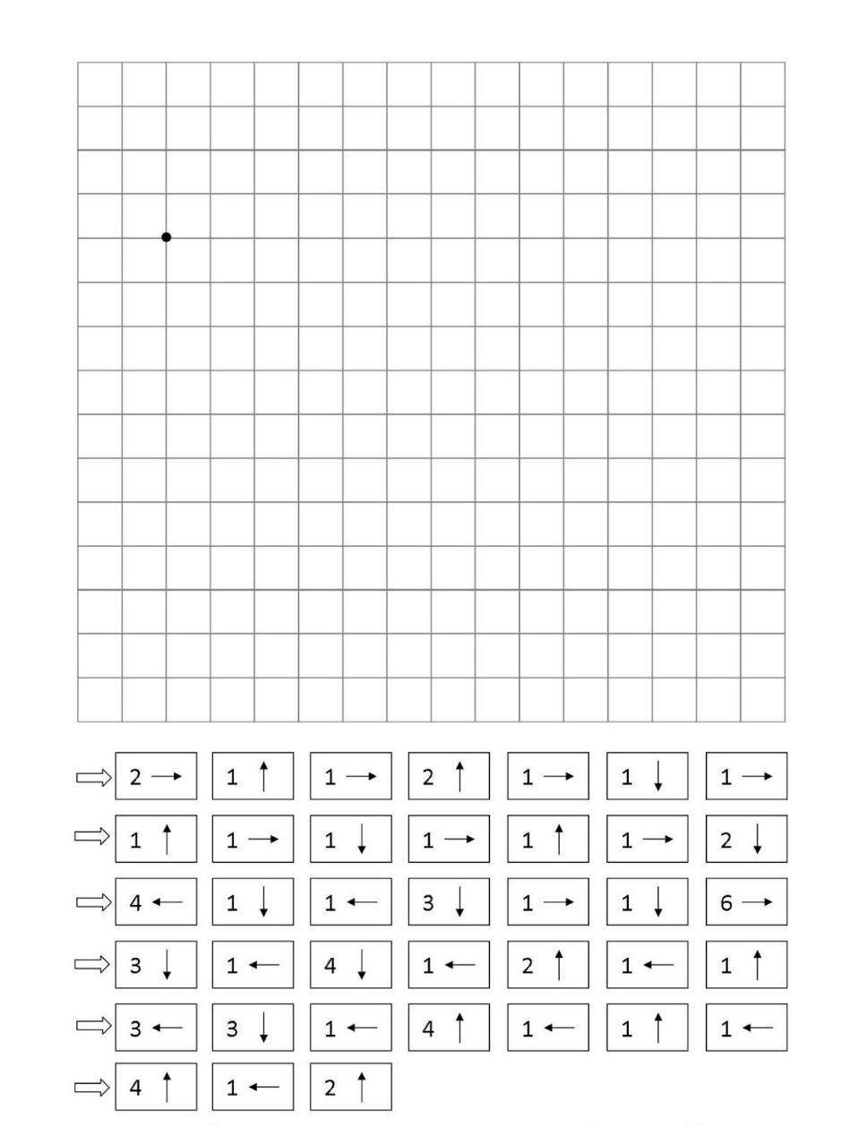

ьнело

СЮРПРИЗ

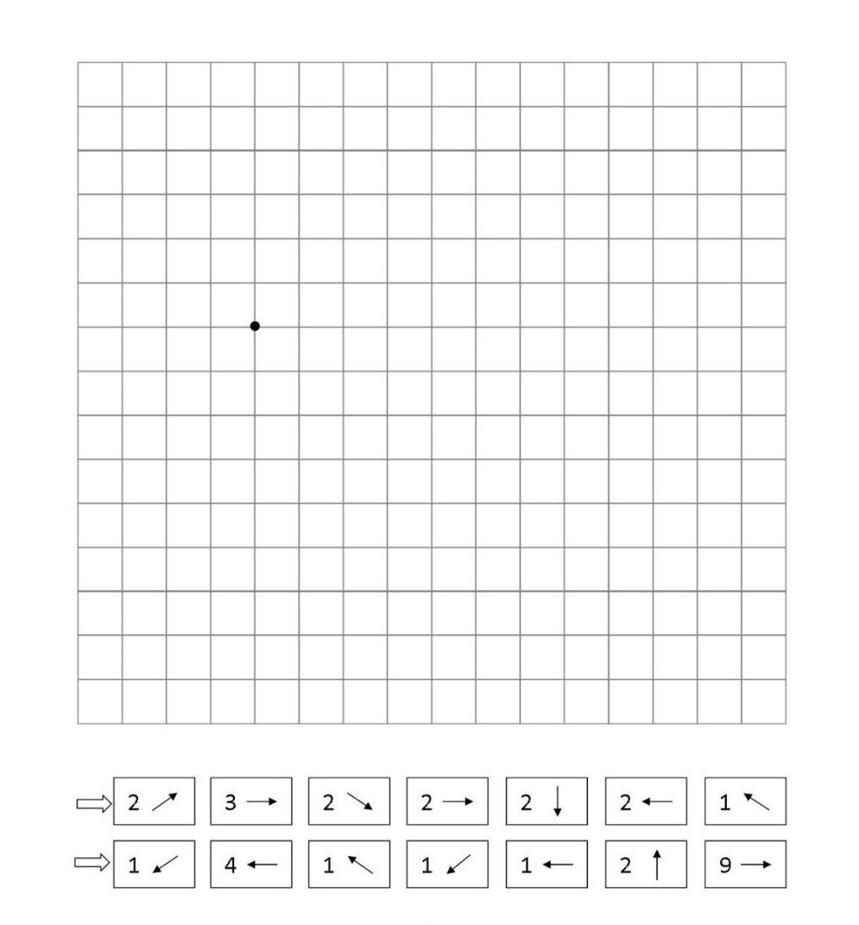

анишам

СЮРПРИЗ

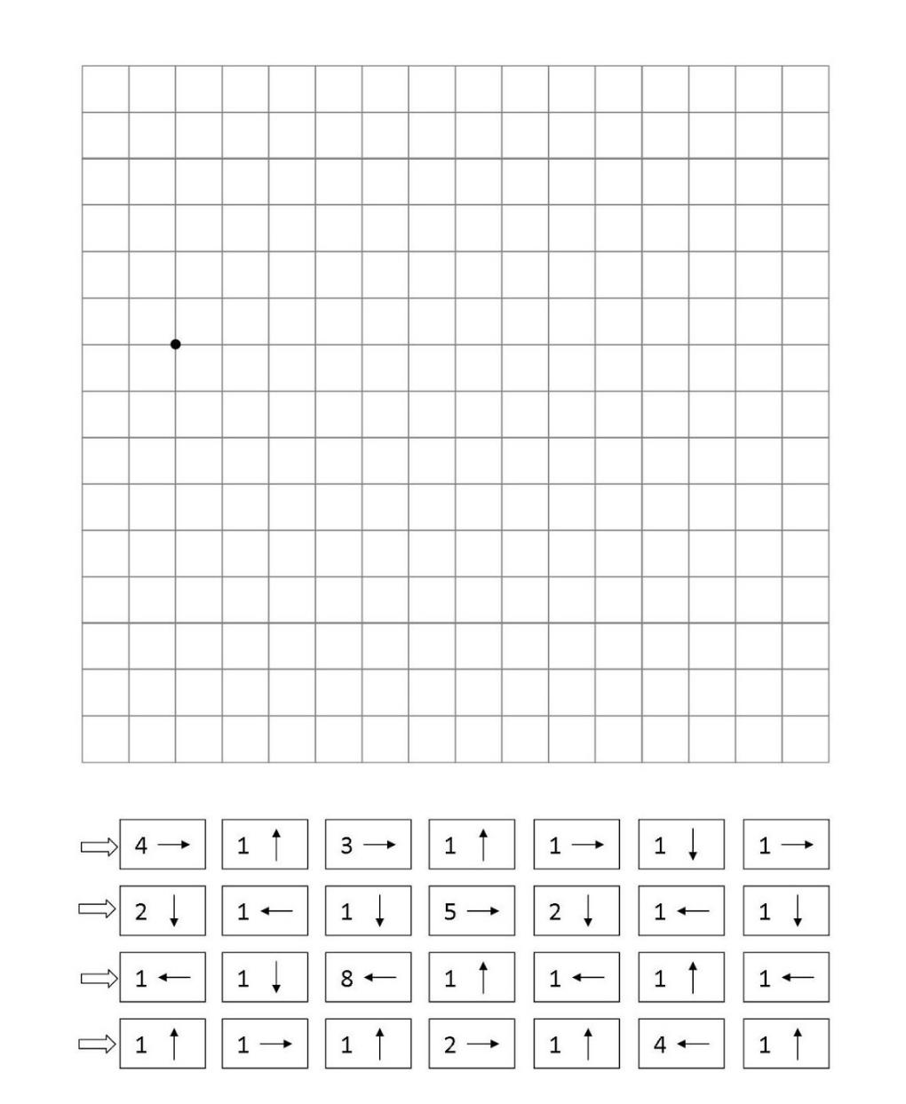

кнат

СЮРПРИЗ

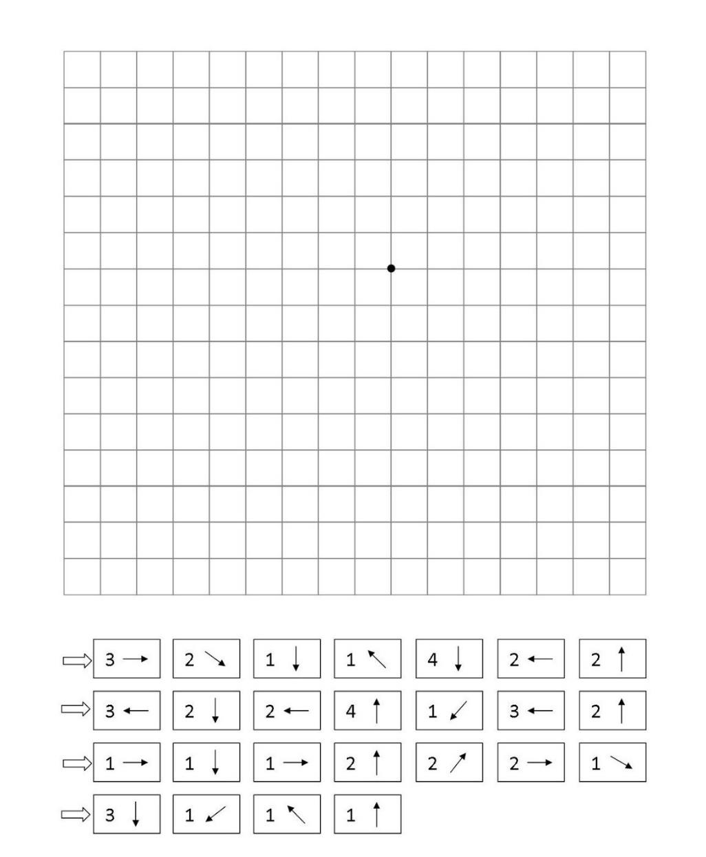

нолс

СЮРПРИЗ

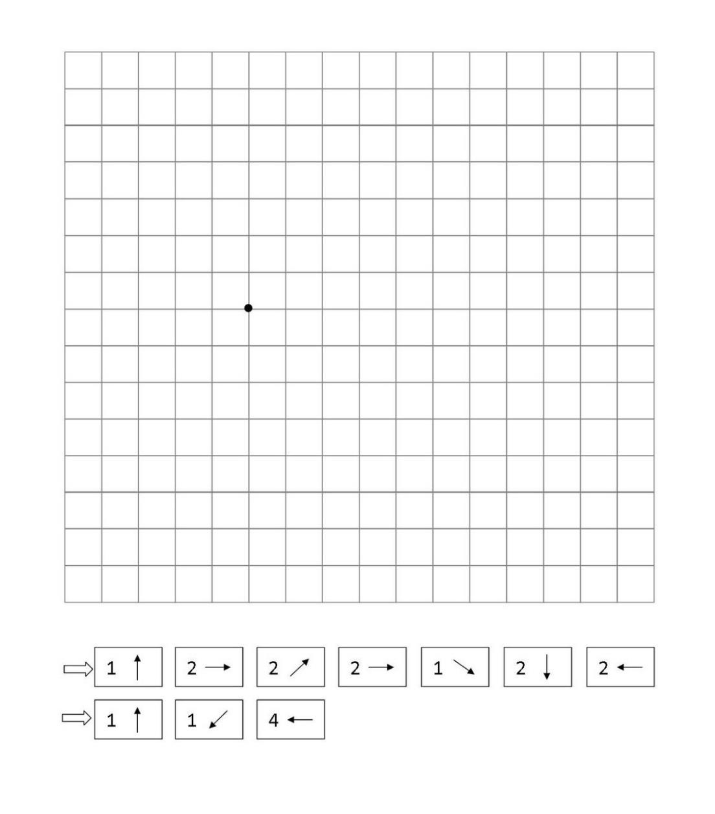

конитоб

СЮРПРИЗ

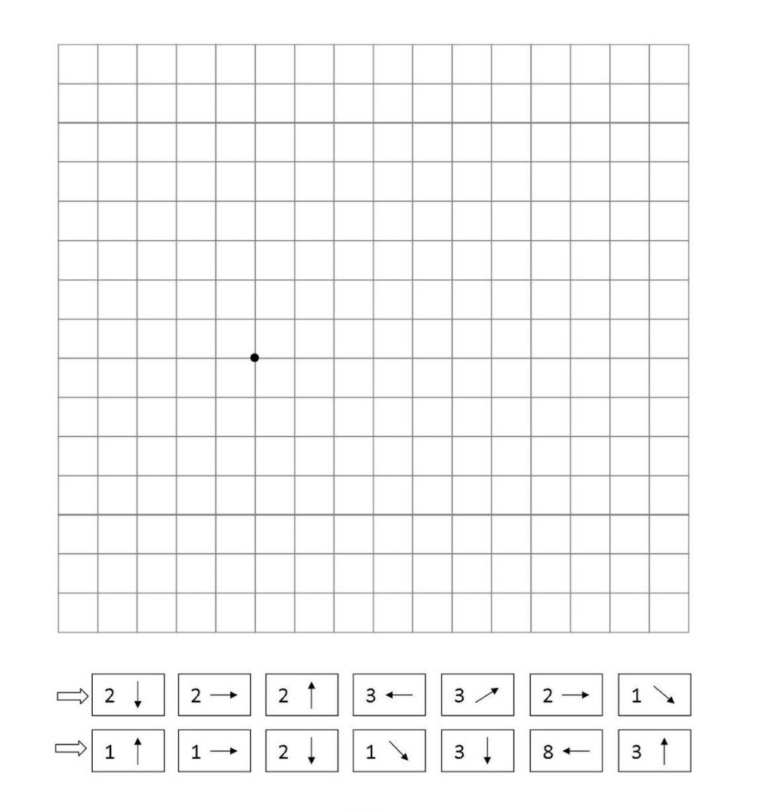

мод

СЮРПРИЗ

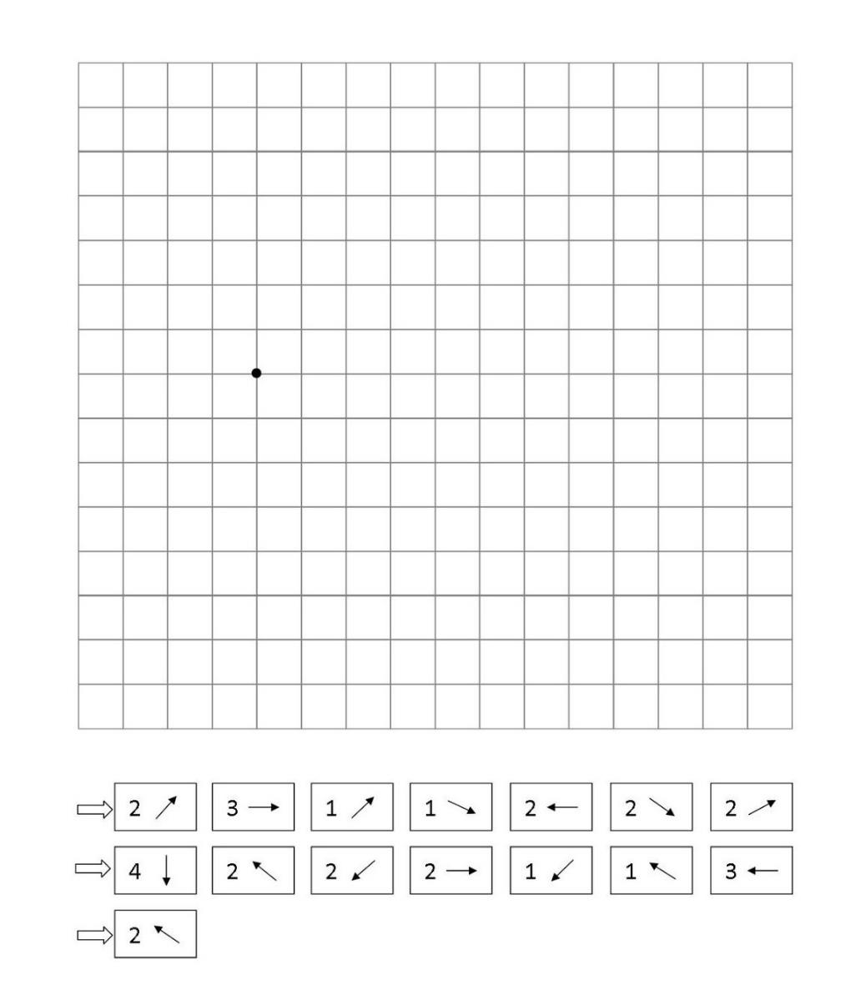

ыбар



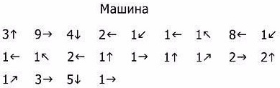



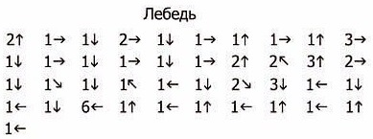



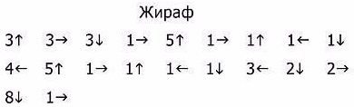



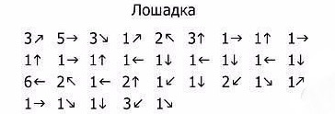



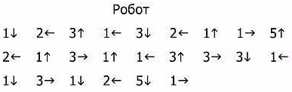



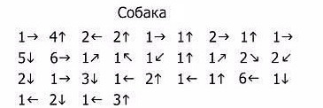



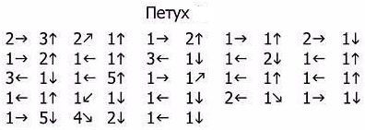



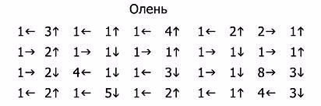



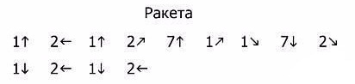

**Задания для самостоятельной работы.**

Скопируй узоры.

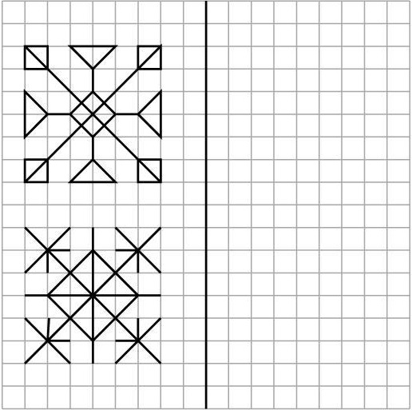

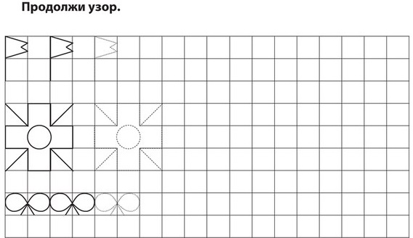

Обведи узор по пунктирной линии и продолжи по образцу.

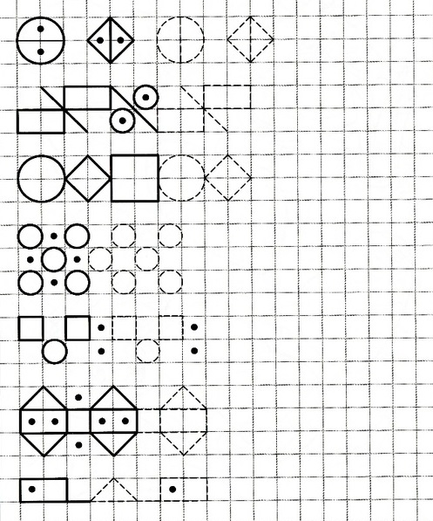

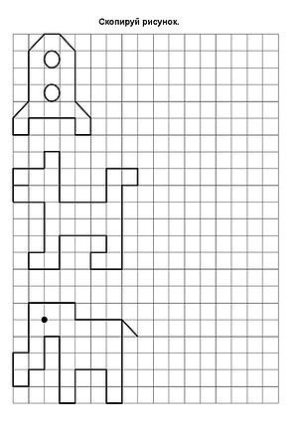

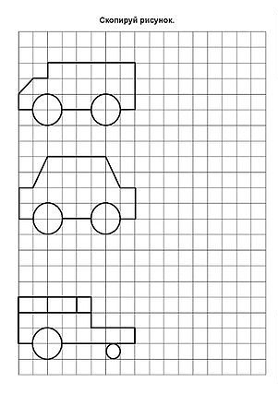

Скопируй рисунки, отступив от образца одну клетку. Раскрась.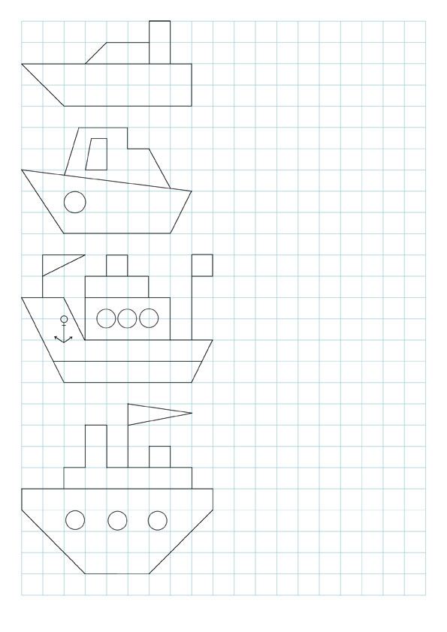

СЮРПРИЗ

Задание для ребенка: постарайся самостоятельно сделать графический диктант, цифра укажет количество клеток, а стрелка направление движения по странице. Не забывай зачёркивать каждый пройденный шаг. Вперёд!



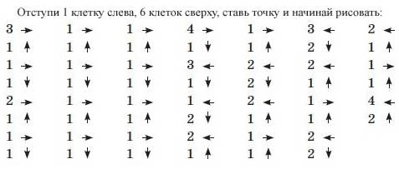

Что у тебя получилось? Раскрась рисунок.

СЮРПРИЗ

Задание для ребенка: постарайся самостоятельно сделать графический диктант, цифра укажет количество клеток, а стрелка направление движения по странице. Не забывай зачёркивать каждый пройденный шаг. Вперёд!



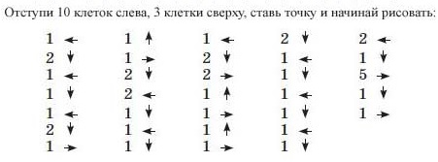

Что у тебя получилось? Раскрась рисунок.

**Задания повышенной сложности.**

Скопируй рисунок.

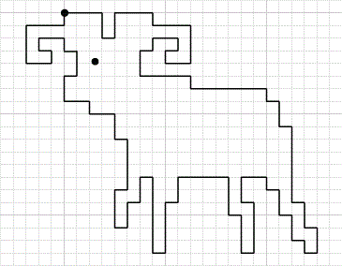

Скопируй рисунок.

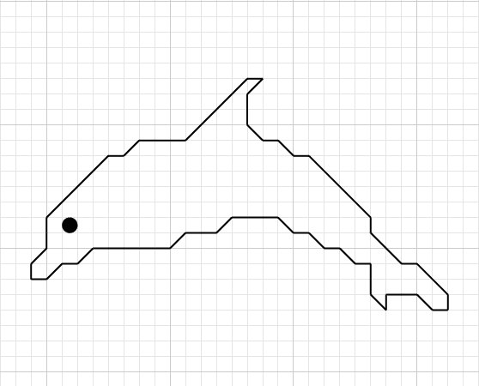



Скопируй рисунок.

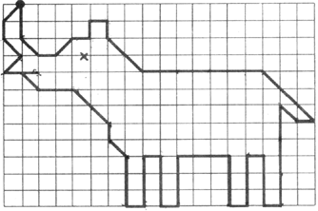



Скопируй рисунок.

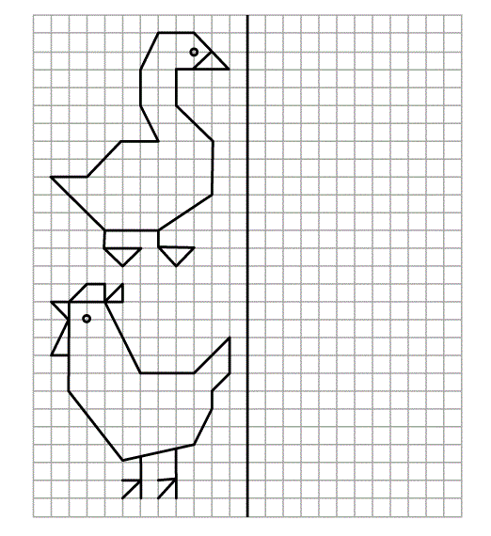

Скопируй рисунок.

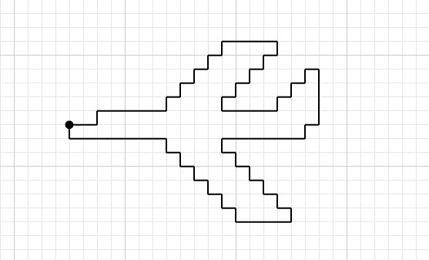



Дорисуй недостающие детали самолета.

Скопируй рисунок.

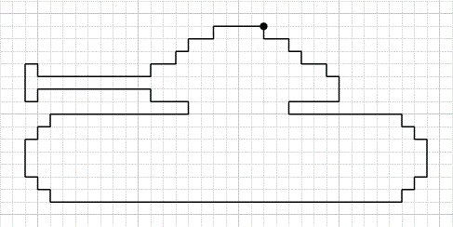



Дорисуй недостающие детали танка.

Попробуйте нарисовать необычный узор из трёх замкнутых линий.

На "старте" на листе в клеточку отмечены 3 точки.

Каждая точка - начало и конец одной линий, т.е. узор состоит из трех замкнутых линий.

Каждую линию рисуем своим цветом.  После окончания закрашиваем узор. Удачи!

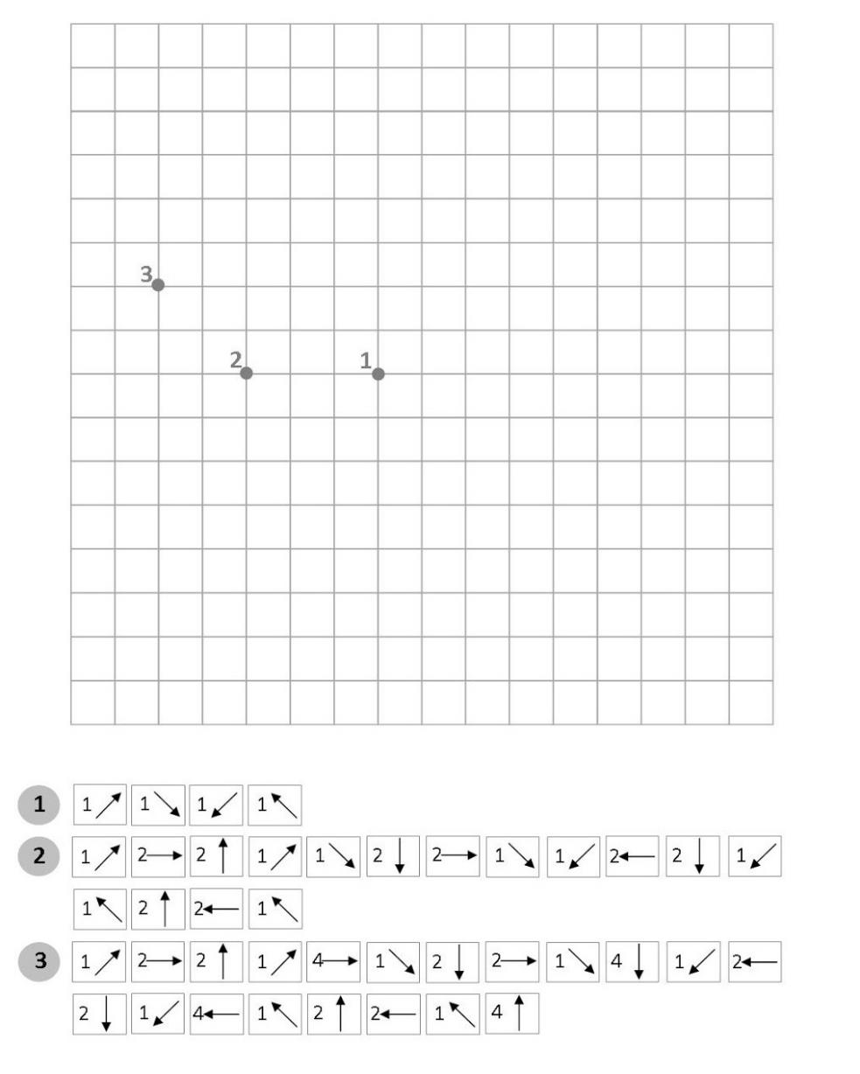

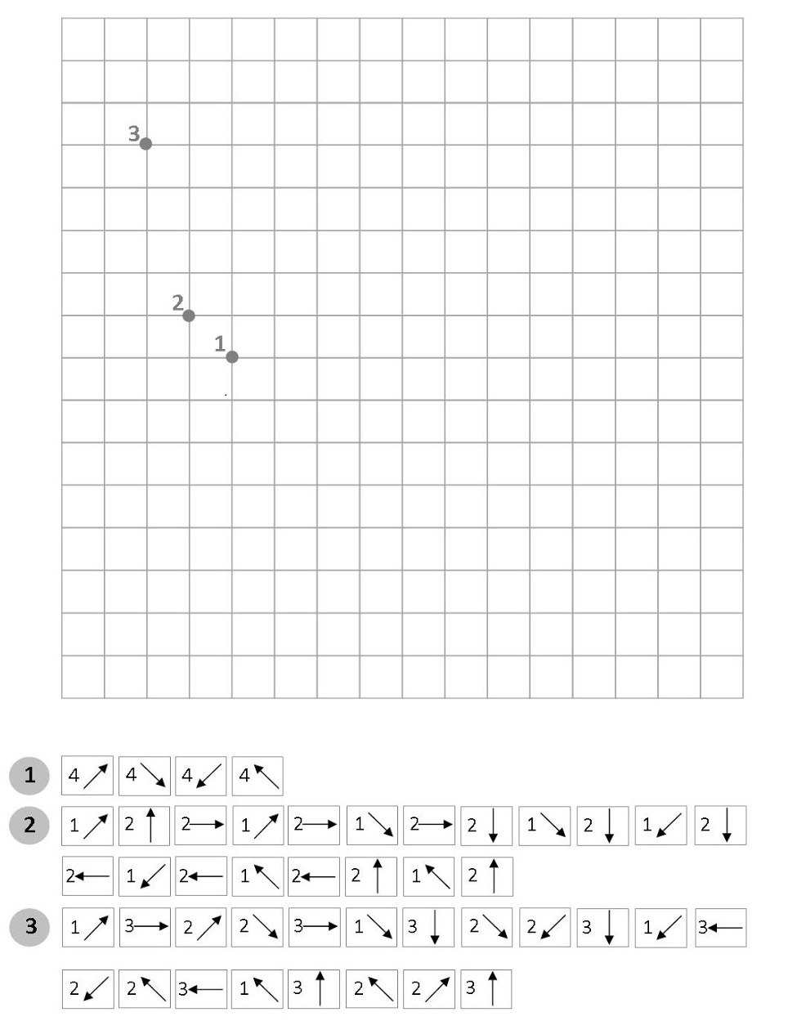

Список литературы

1. Голубь В.Т. Графические диктанты: Пособие для занятий с детьми 5-7 лет. – М.: ВАКО, 2010. – 144 с. – (Дошкольники: учим, развиваем, воспитываем; Мастерская учителя;).
2. Дружок. Графические диктанты. Картинки в клеточках /Автор Васильева И., Издательство: Стрекоза, 2010.
3. Дружок. Графические диктанты для девочек /Автор Васильева И., Издательство: Стрекоза, 2010.
4. Дружок. Графические диктанты для мальчиков /Автор Васильева И., Издательство: Стрекоза, 2010.
5. Рахманова Е.М. «Графические диктанты для дошкольников», М.: Владос, 2008.
6. Сыропятова Г.А. Тетрадь. Графические диктанты, Издательство: Литур, город: Екатеринбург, 2013.
7. Шевелев К.В. Графические диктанты. Рабочая тетрадь для детей 5-6 лет. – М.: Издательство «Ювента», 2006. – 64 с.: илл.
8. <http://nataliigromaster.blogspot.com/2014/02/blog-post_24.html> - Графические диктанты. Распечатай и рисуй.
9. <http://neposed.net/kids-literature/detskie-stihi/stihi-predmetnii-mir/stikhi-pro-transport/stikhi-pro-poezd.html> - Детские стихи
10. <http://www.roditeli.ua/deti/development_poetry/geometric_shapes> - Стихи на тему Геометрические фигуры.
11. <http://skorogovorki.com/skorogovorki-o-zhivotnyih/.html> – Скороговорки о животных